

*Version 23.1.0 for Salesforce Commerce Cloud - SFRA*

**Table of Contents**

**Summary 3**

**Component Overview 4**

*Functional Overview* **4**

*Use Cases* **4**

*Compatibility* **4**

*Privacy, Payment* **4**

**Implementation Guide 5**

*Setup of Business Manager* **5**

*Configuration of Business Manager* **7**

**Testing 9**

*Single Opt-in Widget* **9**

*Multi Opt-in Widget* **10**

*Confirmation Widget* **11**

**Operations, Maintenance 13**

*Data Storage* **13**

*Availability* **13**

*Support* **13**

**User Guide 14**

*Roles, Responsibilities* **14**

**Release History 1**

# **Summary**

This guide describes how to integrate the AirRobe’s Circular Wardrobe Widgets Version 23.1.0 in the SFCC reference application SFRA.

AirRobe’s Circular Wardrobe Widgets Version 23.1.0 cartridge provides the following features:

* A widget to install on the PDP called the Single Opt-in Widget
* A widget to install on the mini-cart and main cart called the Multi Opt-in Widget
* A widget to install on the confirmation page called the Confirmation Widget

1. **Component Overview**

## Functional Overview

AirRobe’s Circular Wardrobe Widgets cartridge provides a way to natively integrate with a brand’s Salesforce B2C Cloud Commerce storefront enabling shoppers to add items to their new digital wardrobe from a brand’s product page.

## Use Cases

The following are what additional functionality are added to a brand’s storefront

* Single Opt-in Widget: Allows shopper to opt in to adding the item on the PDP to their Circular Wardrobe, allows shopper to learn about AirRobe by clicking on “Learn more” in the Widget dropdown, and gives shopper an estimated resale price in the “Potential value” field on the Widget.
* Multi Opt-in Widget: Contains all the functionality as the Single Opt-in Widget except for the “Potential value” field from the mini-cart or main cart page.
* Confirmation Widget: Adds opted-in items to the Circular Wardrobe and opted-out items to the Connector (the system that connects the AirRobe’s Circular Wardrobe Widgets and Circular Wardrobe), and allows shopper to sign up or sign in to AirRobe from the order confirmation page.

## **Compatibility**

Cartridge tested in:

* Compatibility mode: 22.7
* SFRA 6.1.0

## **Privacy, Payment**

The Confirmation Widget requires the order ID and the shopper’s email address.

# **Implementation Guide**

There are no restrictions on what locale the cartridge will work in.

## Setup of Business Manager

If you are a new merchant and do not have the AirRobe’s Circular Wardrobe Widgets cartridge installed on your site, please follow the directions below:

1. *Download the cartridge*
   * You can download it from GitHub: <https://github.com/airrobe/airrobe-salesforce-cartridge/> or from AppExchange: <insert app exchange link here>
2. *Import the cartridge*
   * Import the cartridge using UX Studio. Alternatively, can also use npm run uploadCartridge, or VSCode Prophet plugin.
   * If using npm run uploadCartridge or the VSCode Prophet plugin make sure you have a dw.json file in the root of the cartridge directory. It should contain the following keys:
     + username: The username you use to log into Business Manager
     + password: The password you use to log into Business Manager
     + hostname: The host name of the instance you want to upload the cartridge to.
     + code-version: This is the Code Version you want to deploy to in Administration > Site Development > Code Deployment.
     + cartridgesPath: This may not be required but if it is, use the paths “int_airrobe_core:int_airrobe_sfra”.
3. *Check for file conflicts*
   * Make sure the template and controller changes required for the cartridge do not interfere with changes you’ve made for your own site, or plugins that are running on your site.
   * The following templates are present in the AirRobe’s Circular Wardrobe Widgets cartridge as well as the app_storefront_base cartridge. Thus, the template in AirRobe’s cartridge will override the base template. Since AirRobe’s cartridge was built to work with the base cartridge, this should be fine. However, if you’ve made custom changes to these templates in the base cartridge, or have installed plugins which override these templates, you will need to merge the changes yourself. A 3-way visual merge tool such as Meld (<https://meldmerge.org/>) may be useful for making any necessary changes.
   * It may be useful to refer to that version to see the AirRobe-specific changes in the overridden file. In general, comments have been left in the files to make it easier to identify AirRobe-specific changes vs. base-SFRA content.

| **Template** | **Location & Purpose for Change** |
| --- | --- |
| checkoutButtons.isml | cartridge/templates/default/cart/cart.isml  - This contains the <isinclude> tag that includes the data script and attribute setting script for the Multi Opt-in Widget |
| confirmation.isml | cartridges/app_storefront_base/cartridge/templates/default/checkout/confirmation/confirmation.isml  - This contains the <isinclude> tag that includes the data script and attribute setting script for the Confirmation Widget |
| addToCartButtonExtension.isml | cartridge/templates/default/product/components/addToCartButtonExtension.islm  - This contains the <isinclude> tag that includes the data script and attribute setting script for the Confirmation Widget |

1. *Upload changes if necessary*
   * If you changed any files in the previous step, either in the AirRobe cartridge, or your store’s cartridge, upload those changes to the store server.
2. *Activate the cartridge in the Business Manager*
   * Before the AirRobe functionality can become available to SFRA, the cartridge names have to be added to the cartridge path of the Site’s settings. In order to do this, follow the below instructions:
     1. Log into Business Manager
     2. Navigate to Administration > Sites > Manage Sites.
     3. Click on the target site name and Click on the Settings tab.
     4. In the textbox Cartridges add “int_airrobe_sfra:int_airrobe_core” in front of the existing cartridge path.
     5. Click Apply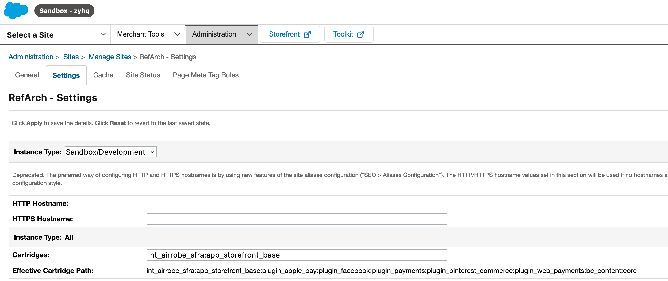
     6. To activate the cartridge for the Sandbox/Development/Production instances repeat steps 4 and 5 after selecting the appropriate instance from the Instance Type dropdown menu.
     7. Repeat steps 3 to 6 for each site that is to use AirRobe’s Circular Wardrobe Widgets cartridge

## **Configuration**

For AirRobe’s Circular Wardrobe Widgets to work you’ll need to use a script URL and App ID customized for your shop that will be sent to you by an AirRobe engineer. Once obtained follow the steps below to set it up in Business Manager:

1. In the CommerceCloud Business Manager dashboard navigate to `Merchant Tools > Site Preferences > Custom Preferences`. There will be a list of custom preference groups (the list will only contain one item, "Storefront Configs", unless you've added other preference groups previously).

2. Click the "New" button.

3. Under "New Attribute Group", fill out the ID field with "AirRobe Configs" and the Name field with "AirRobe Configurations". Click the “Add” button.

4. Three tabs, "General", "Attribute Definitions", and "Attribute Grouping", should be visible at the top of the page. Click "Attribute Definitions".

5. Click "New" (at this writing, it's at the bottom of the table with the existing attributes).

6. Fill out the ID field with "airRobeScriptSrc" and set the Value Type to "String" (this is the default). This name is used programmatically in the AirRobe cartridge so make sure it is spelled and cased correctly.

7. Click "Apply". More fields will appear.

8. Set the "Default Value" field to the URL of the AirRobe script source. (You can set values individually for each of your sites, so it is possible to set different values for staging and production.)

9. Click "Apply".

10. Repeat steps 4-10, setting an attribute called "airRobeAppId" to the App ID for the Salesforce shop in the Connector. Again, this name is used by the AirRobe cartridge, so exact spelling and casing are important.

11. Go back to the "Attribute Grouping" tab.

12. Find the "AirRobe Configs" grouping you created in step 3 in the table and click "Edit" in that row.

13. Under the heading "Assign Attribute Definition", you will see a required "ID" field. To the right of this field, there is a button with three dots. Click this button.

14. Select the "airRobeScriptSrc" and "airRobeAppId" attributes using the checkboxes in the popup window that appears and click "Select".

To customize settings per site:

1. Navigate back to `Merchant Tools > Site Preferences > Custom Preferences`.

2. In the table, click on the "AirRobe Configs" preference group. You'll be taken to a page with a table showing the custom attributes you've chosen ("airRobeScriptSrc" and "airRobeAppId").

3. In each row of the table, there is a link to "Edit Across Sites". Clicking this link will take you to a page where you can set the value of that attribute for each of your sites. It will be populated by default with the default value you set in step 8, above.

4. For each site, change the value of the variable to the desired value and click "Save".

# **Testing**

AirRobe developers will configure the styling to suit the storefront’s styling and the location of the Widgets on the page.

**Single Opt-in Widget**

The Single Opt-in Widget should render on the PDP page.

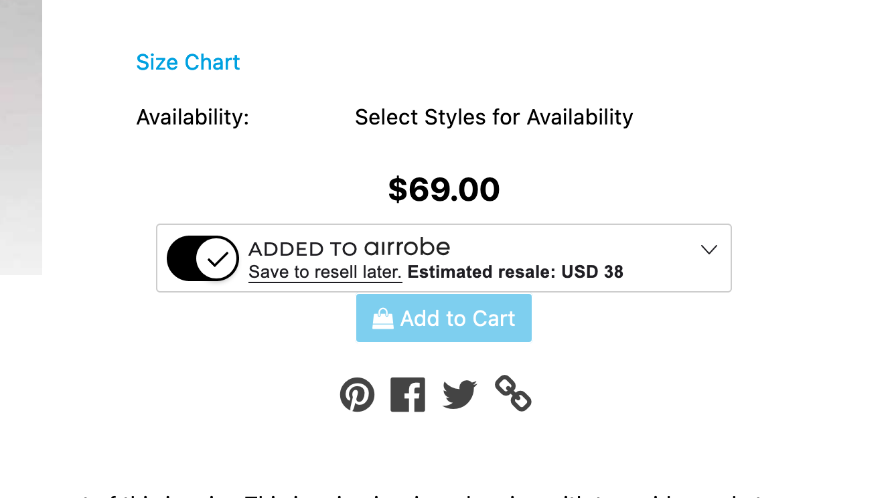

The following behavior should be possible:

* **On Load** - This is the state of the Single Opt-in widget upon load. It should be collapsed, in the opt-out state, with "Add to airrobe" showing, and the potential value loaded in by an API call to the Price Engine.

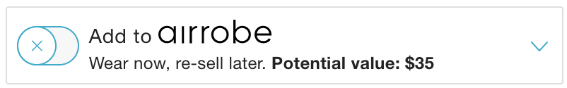

* **Opted In** - This is the state of the Single Opt-in widget when the user opts the product into AirRobe. It should be collapsed, in the opt-in state with "Added to airrobe" showing.

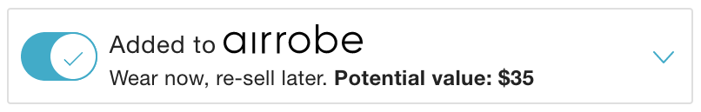

* **Expanded** - This is the state of the Single Opt-in widget when the user expands the widget by clicking on the chevron. It should expand to show this text. Clicking “Learn more” will display the popup.

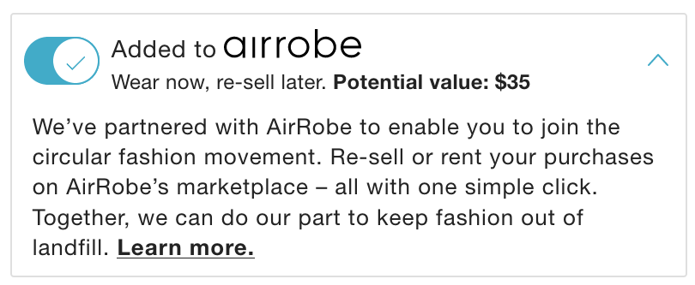

**Multi Opt-in Widget**

The Multi Opt-in Widget should render on the mini-cart and full page cart.

Mini-cart

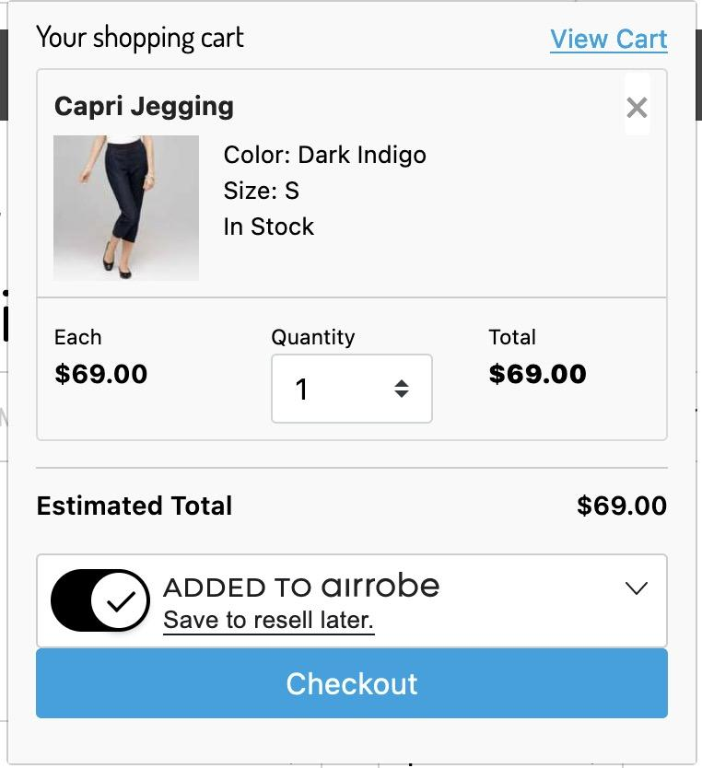

Full page cart

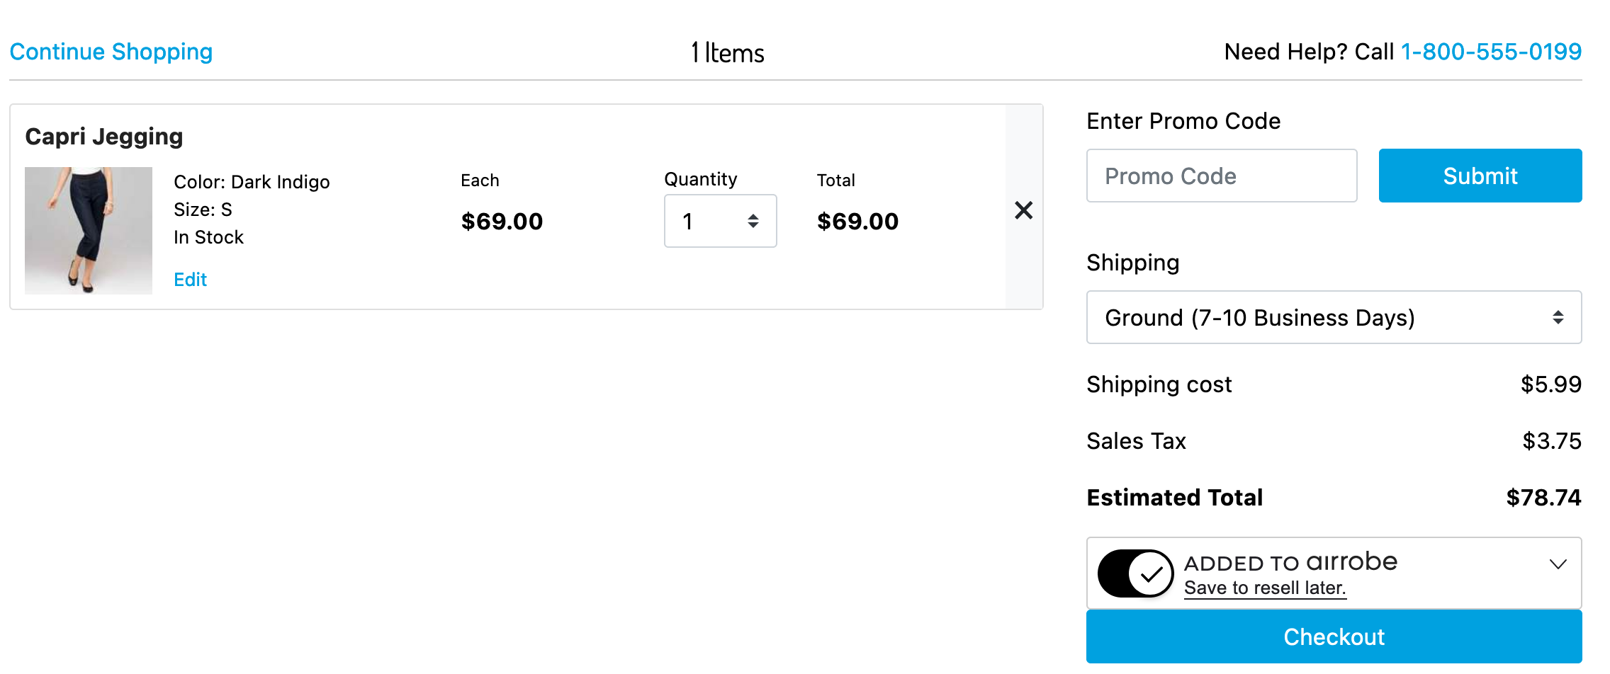

The Multi Opt-in Widget has all of the behavior as the Single Opt-in Widget except it doesn’t display the “Potential value”

The popup is a part of the functionality of the Single Opt-in Widget and the Multi Opt-in Widget and looks like the following:

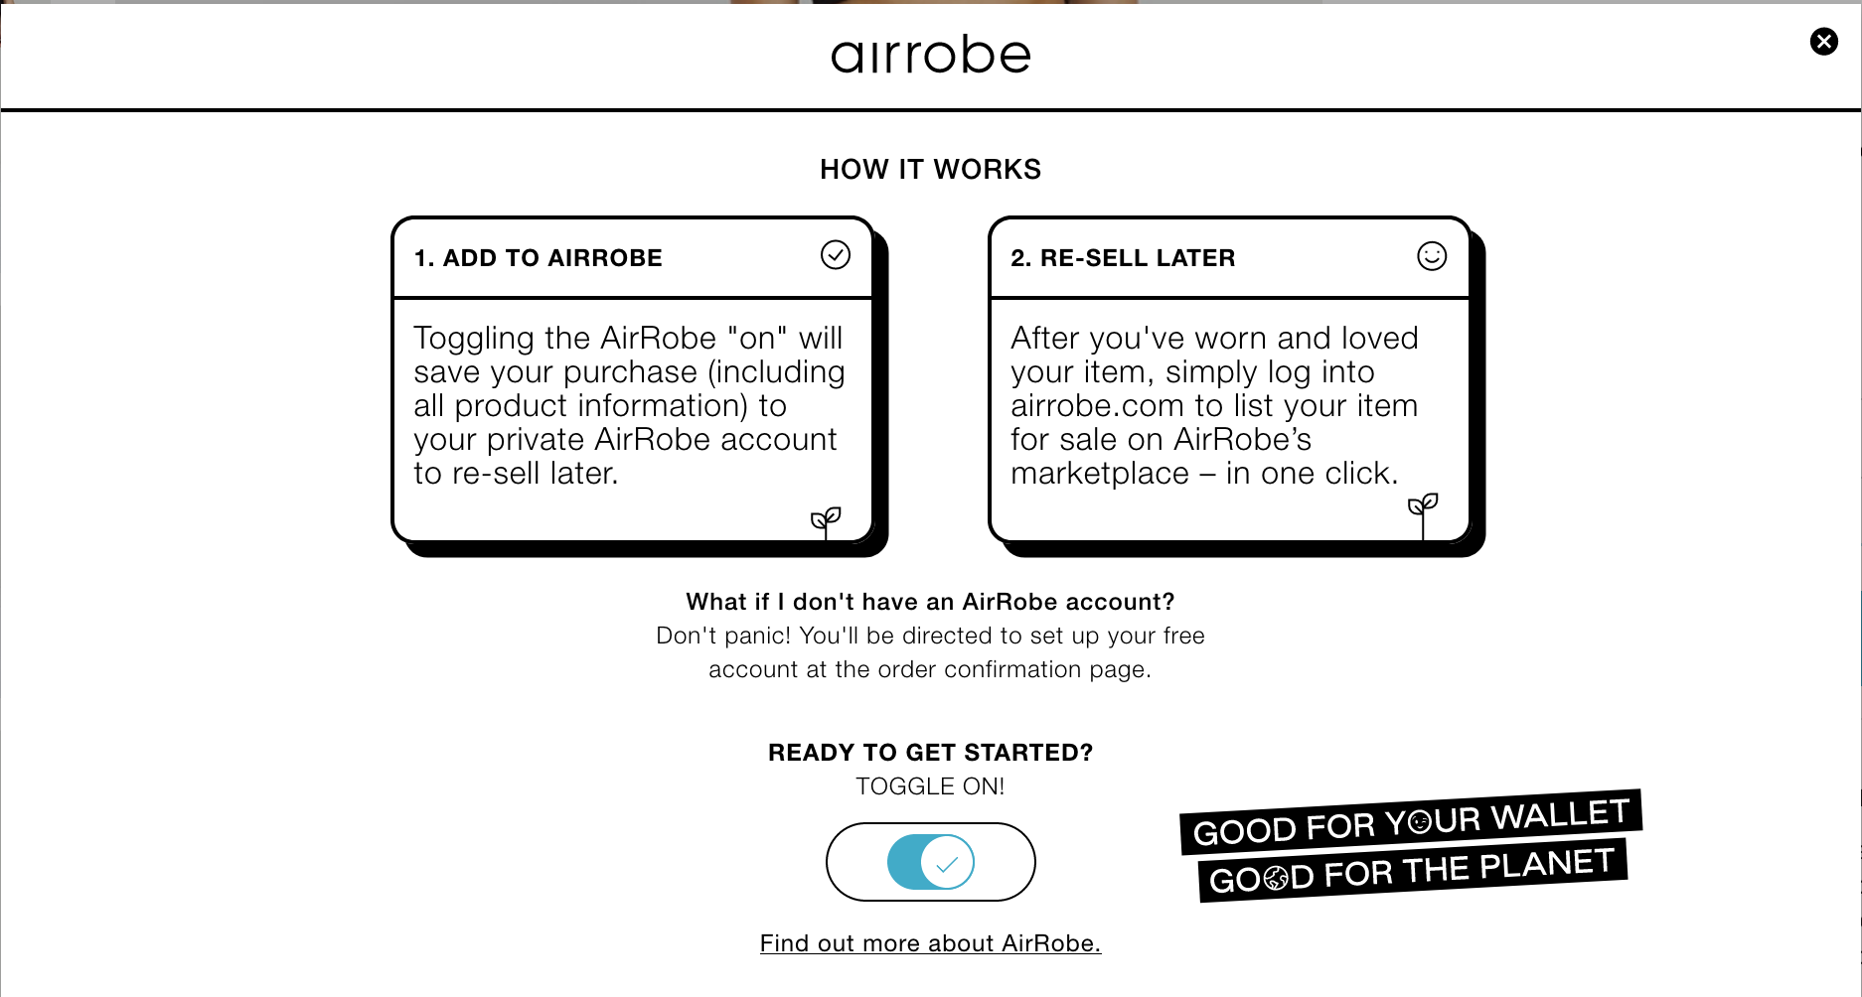

It has an Opt-in/Opt-out toggle and clicking on “Find out more about AirRobe” will open up another tab that links to information about AirRobe. Closing the popup is done by clicking the cross or clicking outside of the popup.

**Confirmation Widget**

The Confirmation Widget should render on the confirmation page if the shopper has opted in at least one product. This will send a request to AirRobe’s identify_order endpoint that will ingest the order into the AirRobe system as an opted-in order.

The Confirmation Widget should not render on the confirmation page if the shopper has opted-out for all products. The widget, even though not rendered, will send a request to AirRobe’s identify_order endpoint that will ingest the order into the AirRobe system as an Opted-out order. The Confirmation Widget can be in the following two states:

* This is the state of the Confirmation widget when the user hasn't activated their account in AirRobe.

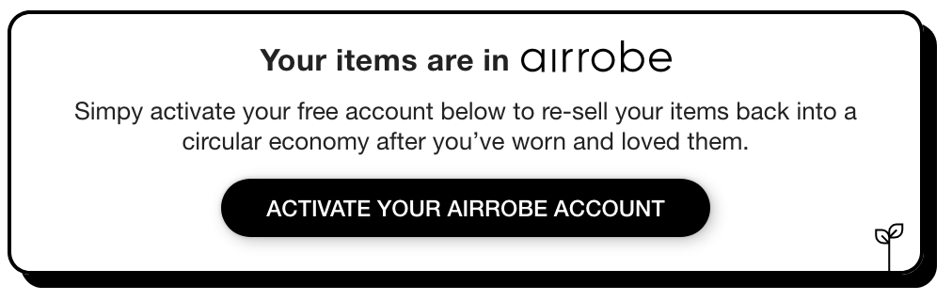

* This is the state of the Confirmation widget when the user has activated their account in AirRobe.

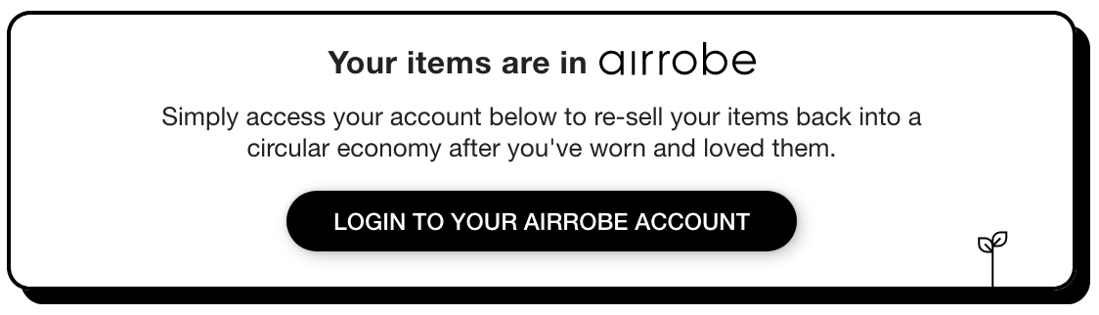

# **Operations, Maintenance**

## **Data Storage**

No data will be stored within the merchant’s storefront.

## **Availability**

If AirRobe’s order ingestion system is unavailable the order ingestion system won’t be able to ingest opted-in or opted-out items. The effect on the shopper is that they won’t be able to add opted-in orders to their Circular Wardrobe.It won’t affect the operations of the storefront.

## **Support**

For support, please get in touch with your AirRobe account contact.

# **User Guide**

## **Roles, Responsibilities**

Integration of this cartridge will typically be done by a SFCC developer.

AirRobe will provide a customized widget URL.

# **Release History**

| **Version** | **Date** | **Changes** |
| --- | --- | --- |
| 23.1.0 |  | Initial release |